INNOVA JUNIOR COLLEGE
JC 2 PRELIMINARY EXAMINATION 2
in preparation for General Certificate of Education Advanced Level
Higher 1

CANDIDATE
NAME

CLASS INDEX NUMBER

CHEMISTRY  Paper 1 Multiple Choice  Additional Materials: Data Booklet  Multiple Choice Answer Sheet | 8872/01  20 September 2010  50 minutes

READ THESE INSTRUCTIONS FIRST

Write your name and class on all the work you hand in.
Write in soft pencil.
Do not use staples, paper clips, highlighters, glue or correction fluid.

There are thirty questions on this paper. Answer all questions. For each question there are four possible answers A, B, C and D.
Choose the one you consider correct and record your choice in soft pencil on the separate Answer Sheet.

Read the instructions on the Answer Sheet very carefully.

Each correct answer will score one mark. A mark will not be deducted for a wrong answer.
Any rough working should be done in this booklet.

This document consists of 12 printed pages.
Innova Junior College [Turn over

Section A

For each question there are four possible answers, A, B, C, and D. Choose the one you consider to be correct.

1 | When 20 cm³ of a gaseous hydrocarbon was completely burnt in an excess of oxygen, 60 cm³ of carbon dioxide and 40 cm³ of water vapour were formed. All volumes are measured at the same temperature and pressure.  What is the formula of the hydrocarbon?
 | A | C₃H₄ | C | C₃H₈
 | B | C₃H₆ | D | C₆H₈

2 | In an experiment, 50 cm³ of a 0.1 mol dm⁻³ solution of a metallic salt reacted exactly with 25 cm³ of a 0.1 mol dm⁻³ sodium sulfite solution. The half-equation for oxidation of sulfite ion is:  SO₃ ²⁻(aq) + H₂O(l) SO₄ ²⁻(aq) + 2H⁺(aq) + 2e  If the original oxidation number of the metal in the salt was +3, what would be the final oxidation number of the metal?
 | A | 0 | C | +2
 | B | +1 | D | +4

3 | Which one of the following corresponds to the configuration of the three electrons of the highest energy for a Group III element?
 | A | 1s² 2s¹
 | B | 2s¹ 2p²
 | C | 3p³
 | D | 4s² 4p¹

4 | The use of Data Booklet is relevant to this question.  In research on the atomic nucleus, scientists have been comparing the stability of isotopes with the same neutron : proton ratio.  Which isotope has the same neutron : proton ratio as ¹⁰B?
 | A | ³²P | C | ³²S
 | B | ⁴⁰Ar | D | ⁴⁰K

5 | The use of Data Booklet is relevant to this question.  The successive ionisation energies, in kJ mol⁻¹, of an element A are given below.  What could A be?
  870 | 1800 | 3000 | 3600 | 5800 | 7000 | 13200
 | A | ₅₁Sb | C | ₄₉In
 | B | ₄₀Zr | D | ₃₄Se

6 | Three substances, D, E and F have physical properties as shown.  What would be the most likely substances of D, E and F?
  substance | melting point/ ºC | boiling point/ ºC | electrical conductivity
  substance | melting point/ ºC | boiling point/ ºC | of solid | of liquid
  D | 801 | 1413 | poor | good
  E | 2852 | 3600 | poor | good
  F | 4827 | 4827 | good | not known
 |  | D | E | F
 | A | NaF | BeCl₂ | Cu
 | B | NaBr | CaO | SiO₂
 | C | NaCl | MgO | graphite
 | D | NaI | Al₂O₃ | diamond

7 | Which of the following molecules exhibits the strongest intermolecular forces?
 | A | HF
 | B | H₂O
 | C | H₂
 | D | HCl

8 | The overall equation for the formation of the red coloured compound G₃H is given below.  3G₂ + H₂ 2G₃H  colourless colourless red  Two experiments were carried out and it was found that the rate of reaction is given by the following relationship:  Rate α 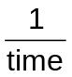  If the rate is found to be Rate = k[G₂][H₂], which of the following statements is not true?
 | A | An increase in the concentration of G₂ will increase the rate of formation of G₃H.
 | B | The rate of consumption of G₂ is three times higher than the rate of consumption of H₂.
 | C | A catalyst added will increase the rate of consumption of G₂.
 | D | The unit of the rate constant is mol⁻¹ dm³ min⁻¹.

9 | If the rate of decay of a radioactive isotope decreases from 1200 counts per minute to 75 counts per minute in 48 hours, what is its half life?
 | A | 6 hours
 | B | 8 hours
 | C | 12 hours
 | D | 16 hours

10 | The decomposition of dinitrogen pentoxide, N₂O₅, was found to be first order with respect to N₂O₅.  Which of the following graphs confirm the result?
 | A  Rate / mol dm^{–3} s^{–1}  [N₂O₅] / mol dm^{–3} |  | C | Rate / mol dm^{–3} s^{–1}  [N₂O₅] / mol dm^{–3}
 | B | Rate / mol dm^{–3} s^{–1}  [N₂O₅] / mol dm^{–3} | D | [N₂O₅] / mol dm^{–3}  Rate / mol dm^{–3} s^{–1}

11 | The equilibrium constants, at 823 K, for two reactions are given below.  What is the numerical value of K_{c} for the following equilibrium at 823 K?  CO₂(g) + H₂(g) CO(g) + H₂O(g)
  CoO(s) + H₂(g) Co(s) + H₂O(g) | K₁ = 67
  CoO(s) + CO(g) Co(s) + CO₂ (g) | K₂ = 490
 | A | 0.137 | C | 423
 | B | 7.313 | D | 557

12 | The pH of a solution mixture containing equal amounts of aqueous ammonia and ammonium chloride is 9.26.  Which of the following happens when 2 cm³ of 0.10 mol dm⁻³ nitric acid is added to the mixture?
 | A | The pH of the resulting solution increases.
 | B | The number of moles of NH₄⁺ ions in the resulting solution increases.
 | C | The number of moles of NH₃ molecules in the resulting solution remains unchanged.
 | D | The ratio of moles of NH₄⁺ ions to NH₃ molecules in the resulting solution decreases.

13 | The table shows some data on two acid-base indicators.  Which conclusion can be drawn about a solution in which bromocresol green is blue and phenol red is yellow?
  Indicator | Approximate pH range | Colour change
  Indicator | Approximate pH range | Acid | Alkali
  Bromocresol green | 3.8 – 5.5 | Yellow | Blue
  Phenol red | 6.8 – 8.5 | Yellow | red
 | A | It is weakly acidic.
 | B | It is neutral.
 | C | It is weakly alkaline.
 | D | It is strongly alkaline.

14 | Titanium(IV) oxide, which is widely used in the paint industry as a white pigment dissolves in hot concentrated sulfuric acid according to the equation.  TiO₂ + H₂SO₄ TiO²⁺ + SO₄^{2–} + H₂O  Which term best describes the above reaction?
 | A | acid-base
 | B | redox
 | C | dehydration
 | D | displacement

15 | The radius and charge of six cations and anions are shown below.  If the ionic solids LM, XK and WI are of the same lattice type, what is the correct order of their lattice energies, placing the one with the highest numerical value first?
  Ion | L⁺ | X²⁺ | W²⁺ | M– | K^{2–} | I^{2–}
  Radius / pm | 220 | 170 | 140 | 180 | 150 | 200
 | A | WI, XK, LM | C | LM, XK, WI
 | B | WI, LM, XK | D | XK, WI, LM

16 | The enthalpy changes for two reactions are given by the equations below.  What is the enthalpy change for the following reaction where silver is obtained from the reduction of silver(I) oxide?  2Ag₂O(s) + C(s) 4Ag(s) + CO₂(g)
  2Ag(s) + O₂(g) Ag₂O(s) | ΔH = –31.0 kJ mol⁻¹
  C(s) + O₂(g) CO₂(g) | ΔH = –393.5 kJ mol⁻¹
 | A | –331.5 kJ mol⁻¹ | C | –850.4 kJ mol⁻¹
 | B | –767.4 kJ mol⁻¹ | D | –1054.4 kJ mol⁻¹

17 | The use of Data Booklet is relevant to this question.  Cyclohexene can be reacted with hydrogen, using a nickel catalyst, to form cyclohexane.  C₆H₁₀(g) + H₂(g) C₆H₁₂(g)  What is the enthalpy change for the reaction?
 | A | –124 kJ mol⁻¹ | C | –944 kJ mol⁻¹
 | B | –560 kJ mol⁻¹ | D | –1380 kJ mol⁻¹

18 | The diagram below shows the energy cycle for the formation of CH₄.  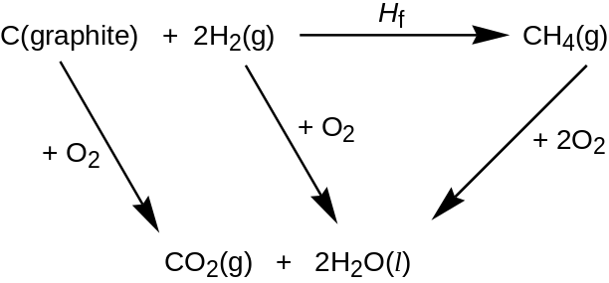  The appropriate enthalpy changes of combustion are given in the table.  What is the enthalpy change of formation of CH₄?
   | ∆H^{θ} / kJ mol⁻¹
  Enthalpy change of combustion of C(graphite) | –393.5
  Enthalpy change of combustion of hydrogen | –285.8
  Enthalpy change of combustion of CH₄ | –890.4
 | A | –74.7 kJ mol⁻¹ | C | 74.7 kJ mol⁻¹
 | B | –211 kJ mol⁻¹ | D | 211 kJ mol⁻¹

19 | Both sodium and magnesium burn in oxygen.  What would be observed when the two metals were burnt separately?
 |  | sodium | magnesium
 | A | yellow flame | yellow flame
 | B | yellow flame | white flame
 | C | white flame | yellow flame
 | D | white flame | white flame

20 | Phosphorus, sulfur and chlorine are Period 3 elements of the Periodic Table. The ionic radii of the three anions are given in the table below.  Which of the following statements correctly explains the trend from P³⁻ to Cl⁻ ?
  Ion | P³⁻ | S²⁻ | Cl⁻
  Radius / nm | 0.212 | 0.185 | 0.181
 | A | The total number of electrons and protons increases.
 | B | The number of electrons decreases and the number of neutrons remain constant.
 | C | The number of electrons remains constant and the number of protons increases.
 | D | The number of electrons increases and the number of protons decreases.

21 | Warfarin is an anticoagulant which is often used as a pesticide against rats and mice.  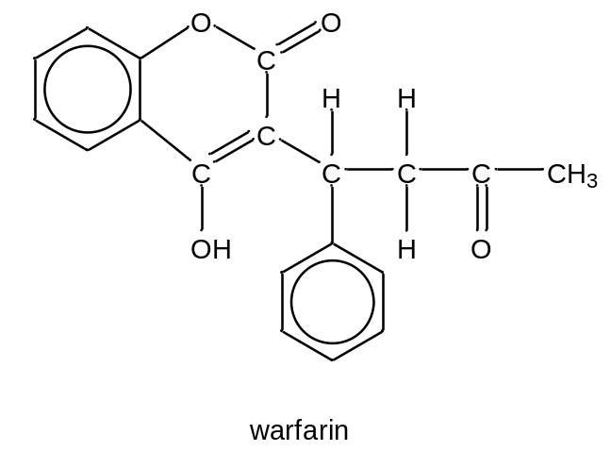  Which statement about warfarin molecule is incorrect?
 | A | It decolourises purple potassium permanganate (VII) under heating.
 | B | It produces HBr as a side product when reacted with aqueous bromine under room temperature.
 | C | It has no geometric isomers.
 | D | It produces a yellow crystal on warming with aqueous, alkaline iodine.

22 | Tetracyanoethylene, C₆N₄ has the molecular formula shown below.  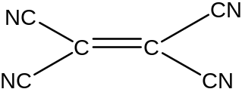  How many sigma and pi bonds are there in one molecule of tetracyanoethylene?
 | A | 5 sigma and 1 pi | C | 9 sigma and 1 pi
 | B | 5 sigma and 9 pi | D | 9 sigma and 9 pi

23 | Which reaction yields a organic product that has more hydrogen atoms than the reactant?
 | A | 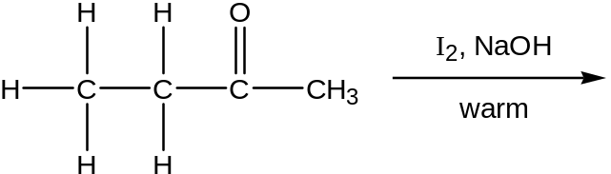
 | B | 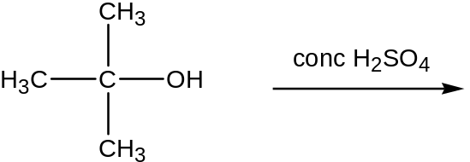
 | C | 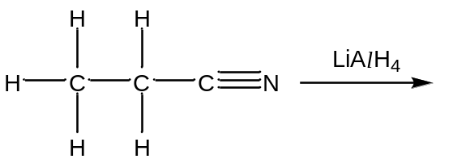
 | D | 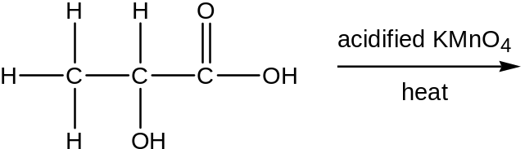

24 | What are the functional groups present in the molecule shown below?  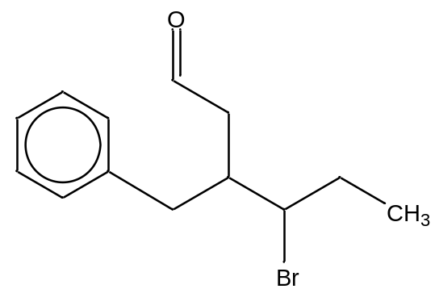
 | A | arene, ketone and secondary alkyl bromide
 | B | arene, ketone and tertiary alkyl bromide
 | C | arene, aldehyde and tertiary alkyl bromide
 | D | arene, aldehyde and secondary alkyl bromide

25 | Compound J has all the following properties.  - It is neutral.  - It gives a red precipitate with Fehling’s solution.  - It decolourises a hot aqueous solution of acidified KMnO₄ with evolution of CO₂ gas.  Which of the following is compound J?
 | A | 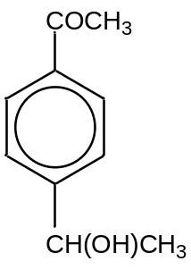 | C | 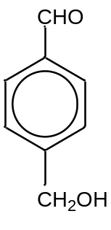
 | B | 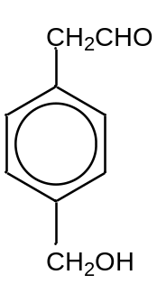 | D | 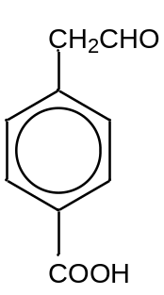

Section B

For each of the questions in this section, one or more of the three numbered statements 1 to 3 may be correct.

Decide whether each of the statements is or is not correct (you may find it helpful to put a tick against the statements that you consider to be correct).

The responses A to D should be selected on the basis of

A | B | C | D
1, 2 and 3 are correct | 1 and 2 only are correct | 2 and 3 only are correct | 1 only is correct

No other combination of statements is used as a correct response.

26 | The reaction between bromine and ethane under ultraviolet light is represented by the equation below:  C₂H₆ + Br₂ 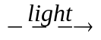 C₂H₅Br + HBr  From the information above, what can be concluded regarding the rate of formation of hydrogen bromide?
  Experiment | Initial concentration/ mol |  | Light intensity | Initial rate of HBr formation
  Experiment | C₂H₆ | Br₂ | Light intensity | Initial rate of HBr formation
  1  2  3  4 | 2  2  1  1 | 1  1  1  2 | 4  1  4  4 | 2  1  1  1
 | 1 | It is directly proportional to the square root of light intensity.
 | 2 | It is not dependent on the initial concentration of bromine.
 | 3 | It is directly proportional to the initial concentration of ethane.

27 | Water dissociates as follows.  H₂O H⁺ + OH– ∆H = +57.2 kJ mol⁻¹ at 298 K  The ionic product of water, K_{w}, is defined as [H⁺][ OH–] = 1 x 10⁻¹⁴ mol² dm⁻⁶ at 298 K.  What deductions can be made from these information?
 | 1 | When water is heated, the concentration of H⁺ increases.
 | 2 | When water is heated, the concentration of OH– increases.
 | 3 | The pH of pure water at temperatures greater than 25 ºC is equal to 7.

The responses A, B, C, and D should be selected on the basis of
A | B | C | D
1, 2 and 3  are correct | 1 and 2  only are correct | 2 and 3  only are correct | 1 only  is correct

No other combination of statements is used as a correct response.

28 | The elements sodium to chlorine are found in Period 3 of the Periodic Table. Which of the following statements explain the general increase in the first ionisation energy of the elements?
 | 1 | The atomic radius decreases across the period.
 | 2 | The nuclear charge increases across the period.
 | 3 | The shielding effect decreases across the period.

29 | Carbonyl compounds undergo condensation reactions with 2,4 dinitrophenylhydrazine as shown in the equation below.  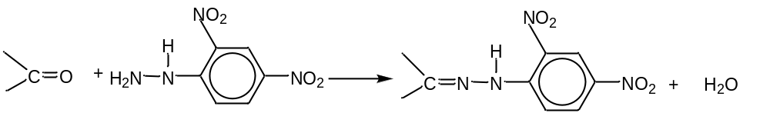  Which pair of compounds could be used to form the compound shown below?  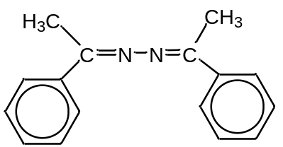
 | 1 | C₆H₅COCH₃ and H₂NNH₂
 | 2 | C₆H₅(CH₃)C=NH and C₆H₅(CH₃)C=NH
 | 3 | C₆H₅CHO and C₆H₅(CH₃)C=NNH₂

30 | Which of the following reagents and conditions will form CH₃CH₂NH₂?
 |  | reagents | conditions
 | 1 | CH₃CH₂Br | excess NH₃(g) in sealed tube, heat
 | 2 | CH₃Br | KCN in ethanol, heat followed by LiAlH₄ in dry ether
 | 3 | CH₃CH₂Br | KCN in ethanol, heat followed by H₂SO₄(aq), heat

